**CBS810 Lab 3: Inference from Compartment Models**

Shi Chen [schen31@ncsu.edu](mailto:schen31@ncsu.edu)

**Learning objectives:**

**Understand the relationship between “Simulation” and “Inference”**

**Know the basics of Sum of Square Error (SSE) and Least Square Estimator (LSE)**

**Estimate the LSE for compartment epidemic models**

**Simulation and Inference**

**Simulation: given (known) parameters, get (simulated) observations**

**Inference: given (actual) observations, get (optimized) parameters**

**Warm-up example of inference: linear regression f(x)=ax+b**

**Error (residual): $r_{i}=y_{i}-f(x_{i}|β(a,b))$**

**Sum of Square Error (SSE): $S=\sum_{i=1}^{n}{r_{i}^{2}}$**

**Least Square Estimator (LSE): The parameter value $\hat{β }$ (a,b) that MINIMIZES *S***

# Linear regression in R

x<-seq(1,10)

**y<-x+**rnorm(10,0.1)

plot(x,y,type="b",ylim=c(-2,12))

fit1<-lm(y~x)

abline(fit1,col="blue")

fit1$coefficients

# (Intercept) slope

# 0.1196246 1.0610377

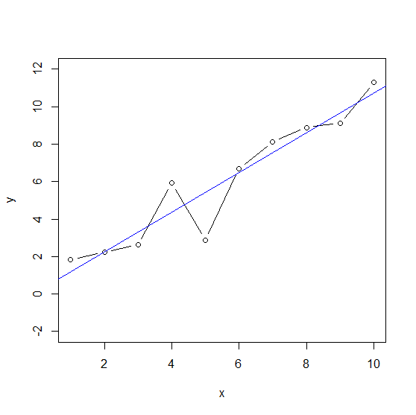

**Inference from the real compartment model**

**The recipe:**

1. **Specify model structure (SIS SIR etc.): how many parameter to estimate?**
2. 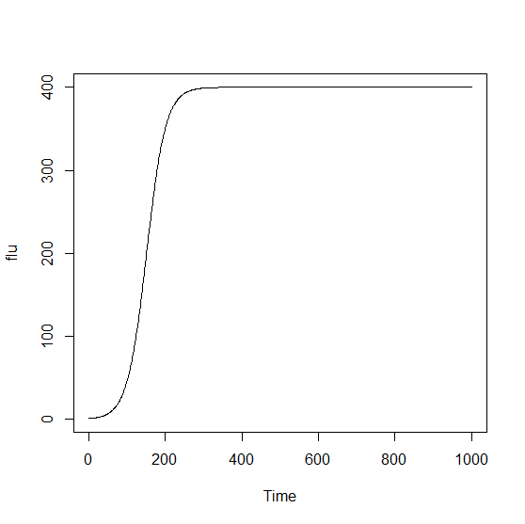**Write (borrow!) the existing simulation function**
3. **Calculate SSE (write a separate function)**
4. **Minimize (optimize) SSE and get LSE**

library(deSolve) # load required package to handle ODE system

load("fluday.Rdat") # load sample observation data

# the dataframe is called "flu.day"

# The model

sis.model <- function (t, x, params) { # We already know this!

S <- x[1]

I <- x[2]

beta <- params[1]

gamma<-params[2]

dS <- -beta*S*I + gamma*I

dI <- beta*S*I - gamma*I

list(c(dS,dI))

}

# The data and SSE

sse.sis <- function(params0,data){ # Function to calculate SSE

t <- data[,1] # Do not confuse with x[1] and x[2]

cases <- data[,2]

beta <- params0[1] # initial value for beta

gamma<-params0[2] # initial value for gamma

S0 <- 499 # initial number of S

I0 <- 1 # initial number of I

out <- as.data.frame(ode(y=c(S=S0,I=I0),times=t,sis.model,parms=c(beta,gamma)))

sse<-sum((out$I-cases)^2) # This is the SSE

}

# The actual optimization (minimization) to get LSE

params0<-c(0.005,0.15)

fit0 <- optim(params0,sse.sis,data=flu.day); fit0$par

fit1 <- optim(fit0$par,sse.sis,data=flu.day); fit1$par